ML & DL : Experiment - 1

Aim:
Implement Linear and Logistic Regression on real-world datasets.

Linear Regression

Dataset Description:
The Netflix Titles Dataset is a real-world dataset widely used in the machine learning domain for data analysis and predictive modeling tasks. It contains detailed information about movies and TV shows available on Netflix.
The dataset consists of multiple observations with various attributes such as title, type, release year, rating, and duration. It is suitable for regression tasks after preprocessing.
The file type used for this dataset is a CSV (Comma Separated Values) file.
The dataset consists of the following columns:
Variable Name | Data Type | Measuring Unit / Format | Description
type | Categorical | Movie / TV Show | Type of content available on Netflix
release_year | Numerical (Integer) | Year | Year of release
duration | Text | "90 min" | Duration of movie

Dataset Source: https://www.kaggle.com/datasets/shivamb/netflix-shows

Theory:
Regression analysis is a method used to study and measure how one main variable that we want to predict (called the dependent or target variable) changes in response to another variable (called independent or predictor variable), while keeping the others fixed. It is used when the result we are predicting is a continuous value, such as age, salary, or temperature. In machine learning and data science, different types of regression are used depending on the pattern in the data.
Two main types of regression algorithms are: Linear Regression and Polynomial Regression.
In linear regression we have one dependent variable and one independent variable. The relation between them will be as follows:

In ML notation:
𝑦 = 𝑚𝑥 + 𝑐

𝑦 = β + β 𝑥

0 1
Where y is the output, x is the input, β₀ is the intercept and β₁ is the slope.
Linear regression is a supervised machine learning algorithm used to predict a continuous dependent variable (target) based on one or more independent variables (features). Its primary goal is to find the "best-fit line" that minimizes the error between the predicted values and the actual values in the dataset. To solve for the values of β₀ and β₁, we have:

β = 𝑛(Σ𝑥𝑦)−(Σ𝑥)(Σ𝑦)
2

β = (Σ𝑦)(Σ𝑥 )−(Σ𝑥)(Σ𝑥𝑦)

1 2 2 0 2 2

𝑛(Σ𝑥
)−(Σ𝑥)
𝑛(Σ𝑥
)−(Σ𝑥)

This method is called the Ordinary Least Squares (OLS) method. Ordinary Least Squares (OLS) is a method used to find the "exact" solution for a linear regression model. OLS uses linear algebra to calculate the optimal parameters in a single mathematical step. The goal of OLS is to minimize the sum of the squared differences (residuals) between the observed values and the values predicted by the linear model.

Limitations:
- The Assumption of Linearity: The most fundamental limitation is that SLR enforces a straight-line relationship on the data. It assumes that for every unit increase in x, the change in y is constant.
Condition of Failure: If the underlying physical or biological relationship is curved (e.g., exponential growth, quadratic curves, or sinusoidal waves), SLR will result in high bias (underfitting).
- Sensitivity to Outliers (Lack of Robustness): Simple Linear Regression uses the "Least Squares" method, which minimizes the squared error. Because errors are squared, a single outlier (a data point far from the rest) contributes disproportionately to the total error.
Condition of Failure: Even one extreme value can "pull" the regression line towards itself, changing the slope and intercept significantly, resulting in a model that fits the outlier but fails the majority of the data.
- Heteroscedasticity (Non-Constant Variance): SLR assumes Homoscedasticity, meaning the "spread" or "noise" of the data remains constant across all values of x.
Condition of Failure: In many real-world datasets, the variance increases as the value of the input increases (a "cone" shape in the data). This violates the assumption that errors are uniform, rendering hypothesis tests (like p-values) unreliable.

Workflow:
- Data Collection: The netflix_titles.csv dataset, is loaded into a Pandas DataFrame. This structure facilitates easy access and prepares the tabular data for processing and model building.
- Data Preprocessing: Movies is selected as the independent input feature (formatted as a 2D structure for scikit-learn), and Movies is the target output. No cleaning is required as the dataset contains no missing or invalid entries.
- Splitting the Dataset: The data is split into training (80%) and testing (20%) sets. This ensures the model learns the relationship without memorizing the data, allowing for an unbiased assessment of its generalization ability on new data.

- Model Training: A Linear Regression model is trained to find the best-fitting line between Shows and Movies. The algorithm calculates the optimal slope and intercept to minimize the error between predicted and actual Moviess, capturing the underlying trend.
- Prediction: The trained model applies the learned linear equation to the unseen test Shows values to generate Movies predictions. These are compared against actual Moviess to assess performance.
- Model Evaluation: Performance is measured using the R² score (ranging from 0 to 1), where a value closer to 1 indicates better accuracy. The final learned slope and intercept are displayed to define the regression equation.
- Data Visualization: A scatter plot displays the actual test data points against the predicted regression line. This visualizes the model's fit and shows how close the predictions are to the actual values.
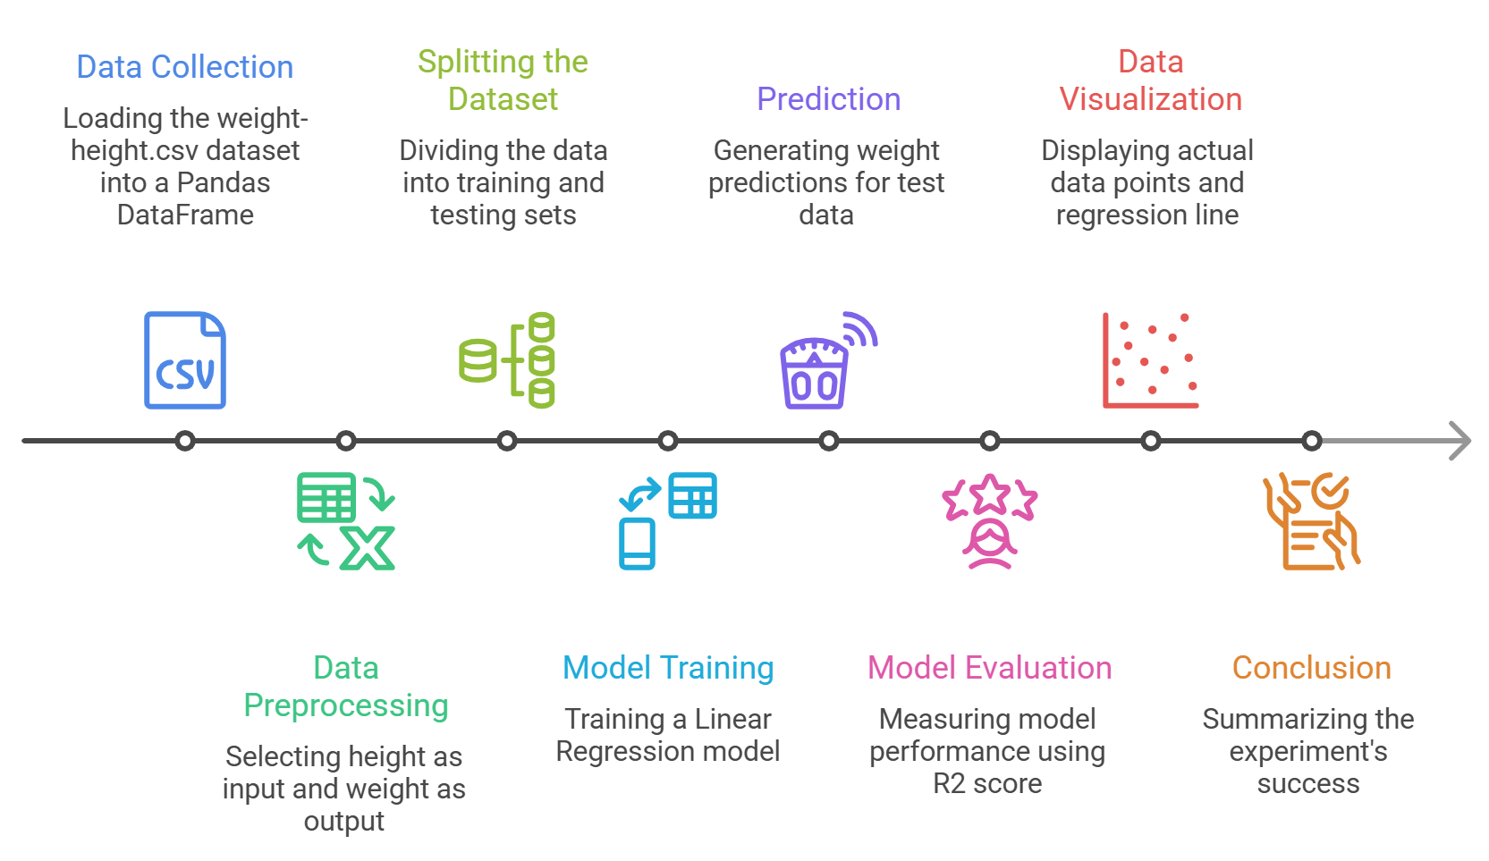
- Conclusion: The experiment successfully demonstrates using Simple Linear Regression to predict Movies from Shows. The R² score and visualization confirm a linear relationship and the effectiveness of the model.

Performance Analysis:
The performance of the implemented Simple Linear Regression model is evaluated using the R² score, along with an analysis of the learned slope (coefficient) and intercept values.

R² Score (Coefficient of Determination):
The value for R² is 0.8577. This means that approximately 85.77% of the variation in Movies can be explained by the Shows of a person. This indicates that Shows is a strong predictor of Movies in the given dataset. Since the R² value is close to 1, the model shows good accuracy and strong predictive performance. The remaining 14.23% of the variation may be due to other factors such as body composition, gender, age, or lifestyle, which are not included in this model.
Hence, the model demonstrates a good fit for the data.

Interpretation of the Slope (Coefficient):
The learned slope (coefficient) value is 7.7022. This indicates that for every 1 inch increase in Shows, the model predicts an average increase of approximately 7.7 pounds in Movies. This confirms a positive linear relationship between Shows and Movies. The value of the slope reflects how strongly Movies changes with respect to Shows.

Intercept:

The obtained intercept value is -349.7878. This means that when Shows is considered as zero, the model predicts a Movies of -349.78 pounds. Although this value has no physical meaning in real life, it is a mathematical artifact required to form the linear equation. The intercept helps position the regression line correctly relative to the data points.

Hyperparameter Tuning:
Hyperparameter tuning is the process of selecting the best set of parameters that control the learning behavior of a machine learning algorithm. These parameters are not learned from the data but are set manually before training, such as learning rate, number of iterations, regularization strength, tree depth, etc. Proper tuning of hyperparameters can significantly improve the performance and accuracy of many machine learning models.
Unlike many other machine learning algorithms, linear regression does not have any major tunable hyperparameters that control the training process. The model directly computes the best-fitting line using a mathematical formula. Therefore, there is no scope for hyperparameter tuning in this experiment.

Code & Output:
import pandas as pd
import matplotlib.pyplot as plt
from sklearn.model_selection import train_test_split
from sklearn.linear_model import LinearRegression
from sklearn.metrics import r2_score
# -----------------------------
# Load LOCAL dataset (uploaded in Colab)
# -----------------------------
df = pd.read_csv("netflix_titles.csv") # <-- change name if different
print("First 5 records:")
print(df.head())
# -----------------------------
# Data Cleaning
# -----------------------------
# Keep only Movies
df = df[df['type'] == 'Movie']
# FIX: use raw string r'(\d+)' to avoid warning
df['duration_minutes'] = df['duration'].str.extract(r'(\d+)').astype(float)
# Drop missing values
df = df[['release_year', 'duration_minutes']].dropna()
# -----------------------------
# Define Features and Target
# -----------------------------
X = df[['release_year']]
y = df['duration_minutes']
# Train/Test Split
X_train, X_test, y_train, y_test = train_test_split(
X, y, test_size=0.2, random_state=42
)
# -----------------------------
# Train Model
# -----------------------------
model = LinearRegression()
model.fit(X_train, y_train)
# Predictions
y_pred = model.predict(X_test)
# Evaluation
r2 = r2_score(y_test, y_pred)
print(f"\nModel Accuracy (R^2 Score): {r2:.4f}")
print(f"Coefficient (Slope): {model.coef_[0]:.4f}")
print(f"Intercept: {model.intercept_:.4f}")
# -----------------------------
# Visualization
# -----------------------------
plt.figure(figsize=(10, 6))
plt.scatter(X_test, y_test, alpha=0.5, label='Actual Data')
plt.plot(X_test, y_pred, linewidth=2, label='Regression Line')
plt.title('Simple Linear Regression: Release Year vs Duration')
plt.xlabel('Release Year')
plt.ylabel('Duration (Minutes)')
plt.legend()
plt.grid(True, linestyle='--', alpha=0.5)
plt.show()

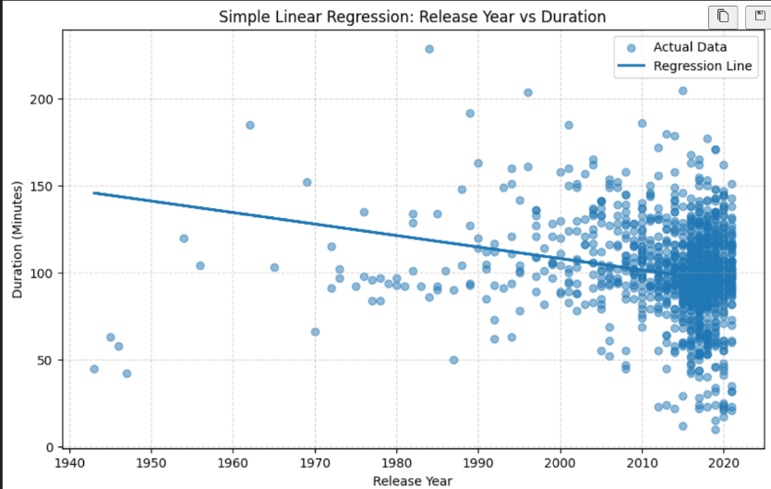

Logistic Regression

Dataset Description:
The Advertising Dataset is a multivariate dataset widely employed in the machine learning domain for binary classification tasks, specifically Logistic Regression. It comprises a collection of 1,000 observations representing the internet usage behaviors and demographic characteristics of web users. The primary objective associated with this dataset is to predict user engagement—specifically, whether a user will click on an advertisement—based on a set of independent features. The dataset is notable for its mix of numerical, categorical, and temporal data types, offering a comprehensive scenario for feature engineering and model evaluation. The file format utilized for this dataset is CSV (Comma Separated Values).
The dataset consists of 10 columns/features, detailed as follows:
Variable Name | Data Type | Measuring Unit / Format | Description
Daily Time Spent on Site | Numerical (Float) | Minutes | Total time a consumer spent on the website during a session; indicates user engagement.
Age | Numerical (Integer) | Years | Age of the consumer; useful for demographic analysis and ad interaction trends.
Area Income | Numerical (Float) | Currency (USD) | Average income of the consumer’s geographical area; represents socioeconomic status.
Daily Internet Usage | Numerical (Float) | Minutes | Average time the consumer spends on the internet per day across all websites.

Dataset Source:

https://www.kaggle.com/datasets/shivamb/netflix-shows

Theory:
Logistic Regression is a statistical method and a supervised machine learning algorithm used for classification problems. Unlike Linear Regression, which predicts continuous values (like salary or temperature), Logistic Regression predicts the probability that a given input belongs to a specific category. It is most commonly used for binary classification, where the target variable has only two possible outcomes (e.g., Yes/No, 0/1, True/False).
While the name contains "regression," it is fundamentally a classification algorithm. It estimates the relationship between a dependent binary variable and one or more independent variables by estimating probabilities using a logistic function.
In Linear Regression, we fit a straight line (y = mx + c). However, for classification, a straight line is unsuitable because:
- It can predict values greater than 1 or less than 0, which are invalid for probabilities.
- It does not handle the "S-shape" transition between classes effectively.
To solve this, Logistic Regression takes the linear equation and "squashes" the output to a value between 0 and 1. It does this using the Sigmoid Function (also called the Logistic Function).
The hypothesis in Logistic Regression transforms the linear input into a probability between 0 and 1. The formula for the Sigmoid function is:

1
𝑦 =
−𝑧

1+𝑒
Here z is called an optimizer function. The value of z is as follows:
𝑧 = 𝑏 + 𝑏 𝑥

0 1

Therefore we can say that:
1
−(𝑏 +𝑏 𝑥)
𝑦 =

1+𝑒 0 1
Note that:
- If z is a large positive number, σ(z) approaches 1.
- If z is a large negative number, σ(z) approaches 0.
- If z = 0 sigma(z) = 0.5
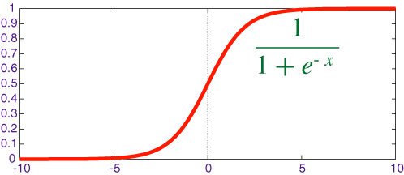
Graph of the Sigmoid Function: The Sigmoid function (specifically the logistic function) creates an "S"-shaped curve. It maps any real-valued number (from -ve infinity to +ve infinity) to a value strictly between 0 and 1.
The curve starts very close to 0 on the left, rises gradually, steeps sharply in the middle, and then levels off very close to 1 on the right. When the input z is exactly 0, the output is exactly 0.5. This is the "indecisive" point where the probability is 50/50.

Limitations:
While Logistic Regression is powerful it has specific structural limitations that make it unsuitable for certain types of data and problems.

Linearity of the Decision Boundary
The most significant limitation is that Logistic Regression is a linear classifier.
  - The Constraint: It assumes that the data can be separated by a straight line (in 2D), a plane (in 3D), or a hyperplane (in higher dimensions).
  - The Failure Case: If your data classes are separated by a circle, a spiral, or any complex non-linear shape, Logistic Regression will fail to capture the pattern effectively.

Impact of Outliers
The Sigmoid function attempts to minimize the error across all data points.
  - The Issue: An extreme outlier (a data point that is far away from the rest) can pull the decision boundary significantly toward itself as the model tries to minimize the error for that one specific point.
  - Result: This "shift" can degrade the accuracy for the majority of the "normal" data points.

Requirement for Large Sample Sizes
Logistic Regression relies on "Maximum Likelihood Estimation" (MLE) to find the parameters. MLE is statistically consistent, meaning it gets closer to the truth as the sample size grows.
  - The Constraint: On very small datasets, the estimates can be biased or inaccurate.
  - Rule of Thumb: A common guideline is that you need at least 10 observations per feature (independent variable) for the model to be stable.

Workflow:
- Data Collection: The advertising.csv dataset, containing 1,000 user behavior observations, is loaded into a Pandas DataFrame. This allows for efficient manipulation, dimension verification, and an initial inspection of feature types and distributions.
- Data Preprocessing: Non-numerical columns (Ad Topic Line, City, Country, Timestamp) are dropped to simplify inputs. The remaining numerical predictors—Time Spent, Age, Income, and Internet Usage—form the feature matrix (X), while "Clicked on Ad" serves as the target vector (y).
- Splitting the Dataset: Data is partitioned into training (70%) and testing (30%) sets using a random_state of 101 for reproducibility. This separation prevents overfitting and allows for unbiased evaluation on unseen data.
- Hyperparameter Tuning & Model Training: A GridSearchCV process is implemented to find the optimal configuration instead of using
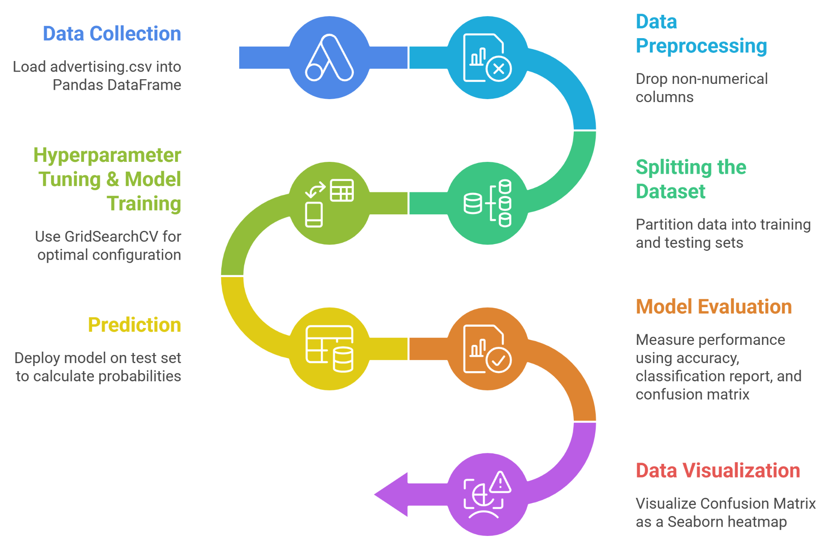
default settings. It performs 5-Fold Cross-Validation on a parameter grid of regularization strengths (C: 0.001 to 1000) and penalties (l1, l2) using the liblinear solver. The "best estimator" is automatically selected.
- Prediction: The optimal model is deployed on the held-out test set (X_{test}) to calculate probabilities. It assigns class labels (0 or 1) based on user features

without prior exposure to the actual target values.
- Model Evaluation: Performance is measured using the Accuracy Score, a Classification Report (precision, recall, F1-scores), and a Confusion Matrix. These metrics detail the overall correctness and specific counts of True/False Positives and Negatives.
- Data Visualization: The Confusion Matrix is visualized as a Seaborn heatmap. This color-coded matrix provides an immediate visual assessment of errors, showing where the model misclassifies clicks versus non-clicks.
- Conclusion: The workflow successfully implements a Logistic Regression classifier optimized via Grid Search. The final metrics and visualizations confirm the model's robust capability to distinguish potential customers from casual browsers effectively.

Performance Analysis:
The performance of the implemented Logistic Regression model is evaluated using the Accuracy Score, the Confusion Matrix, and the Classification Report. These metrics provide a comprehensive assessment of the model's ability to classify users into "Clicked on Ad" (1) and "Did not Click" (0) categories.
- Accuracy Score: The model achieved an Accuracy Score of 97.67%, correctly predicting 293 out of 300 test observations. This confirms that features like Time Spent on Site and Age are highly effective predictors, with a very small margin of error (2.33%).
- Confusion Matrix Analysis: The matrix reveals a detailed breakdown of predictions:
  - True Negatives (155): Correctly identified users who did not click.
  - False Positives (2): Incorrectly flagged "No Click" users as "Click" (exceptionally low false alarm rate).
  - False Negatives (5): Missed only 5 users who actually clicked.
  - True Positives (138): Correctly identified users who clicked.
The high diagonal values (155, 138) versus low off-diagonals (2, 5) confirm the model distinguishes between classes with high precision.

Classification Report
  - Precision (0.99): When the model predicts a click, it is correct 99% of the time, ensuring resource efficiency.
  - Recall (0.97): The model captures 97% of actual clickers, minimizing missed opportunities.
  - F1-Score (0.98): This near-perfect score indicates an optimal balance between precision and recall.

Hyperparameter Tuning:
Hyperparameter Tuning was performed to optimize the Logistic Regression model. Rather than relying on default settings, we used GridSearchCV to systematically test different combinations of parameters. This process ensures the model generalizes well and avoids common pitfalls like overfitting or underfitting.
Hyperparameters Tuned:

C (Inverse Regularization Strength):
Controls the trade-off between model simplicity and fitting accuracy. Smaller values enforce stronger regularization (simpler model). Larger values allow weaker regularization (more complex model). A logarithmic range [0.001,0.01,0.1,1,10,100,1000] was tested.

Penalty:
Determines how large coefficients are penalized.
  - L1 (Lasso): Enables feature selection by forcing some coefficients to zero.
  - L2 (Ridge): Shrinks coefficients without eliminating them.

Solver:
liblinear was used as it supports both L1 and L2 penalties and is efficient for small datasets.
After testing 70 different model combinations (7 C values X 2 penalty types X 5 cross-validation folds), the best model was selected and evaluated on the test set. The best model achieved:
- Accuracy: 97.67%, consistent with the initial model (~98%)
- Precision (Click): 0.99
- Recall (Click): 0.97
- F1-Score: 0.98
The tuned model maintains very high performance, indicating a strong underlying relationship between the features and the target variable.

Code & Output (without hyperparameters):
import pandas as pd
import seaborn as sns
import matplotlib.pyplot as plt

from sklearn.model_selection import train_test_split, GridSearchCV
from sklearn.linear_model import LogisticRegression
from sklearn.metrics import classification_report, confusion_matrix, accuracy_score

# =============================
# LOAD DATASET (UPLOADED IN COLAB)
# =============================
df = pd.read_csv("netflix_titles.csv")

print("Dataset Shape:", df.shape)
print(df.head())

# =============================
# DATA PREPROCESSING (DIFFERENT FROM ADVERTISING DATASET)
# =============================

# Keep useful columns only
data = df[['type','release_year','rating','duration','country']].copy()

# Convert duration to numeric
data['duration_num'] = data['duration'].str.extract(r'(\d+)').astype(float)

# Drop original duration column
data.drop('duration', axis=1, inplace=True)

# Drop missing values
data.dropna(inplace=True)

# Convert TARGET into binary
# Movie = 1 , TV Show = 0
data['type'] = data['type'].map({'Movie':1, 'TV Show':0})

# One-hot encode categorical features
data = pd.get_dummies(data, columns=['rating','country'], drop_first=True)

# =============================
# DEFINE FEATURES + TARGET
# =============================
X = data.drop('type', axis=1)
y = data['type']

# Train/Test Split (70/30 like your code)
X_train, X_test, y_train, y_test = train_test_split(
X, y, test_size=0.3, random_state=101
)

# =============================
# LOGISTIC REGRESSION MODEL
# =============================
logmodel = LogisticRegression(max_iter=2000)
logmodel.fit(X_train, y_train)

predictions = logmodel.predict(X_test)

print("\n--- Model Evaluation ---")
print(f"Accuracy Score: {accuracy_score(y_test, predictions)*100:.2f}%")

print("\nConfusion Matrix:")
print(confusion_matrix(y_test, predictions))

print("\nClassification Report:")
print(classification_report(y_test, predictions))

# =============================
# HEATMAP VISUALIZATION
# =============================
plt.figure(figsize=(6,4))
sns.heatmap(confusion_matrix(y_test, predictions),
annot=True, fmt='d', cmap='Blues')

plt.title('Netflix Type Prediction - Confusion Matrix')
plt.ylabel('True Label')
plt.xlabel('Predicted Label')
plt.show()

# ======================================================
# 🔥 HYPERPARAMETER TUNING (DIFFERENT SETUP)
# ======================================================

param_grid = {
'C': [0.01,0.1,1,10,50],
'penalty': ['l1','l2'],
'solver': ['liblinear']
}
logmodel = LogisticRegression(max_iter=2000)
grid_search = GridSearchCV(
estimator=logmodel,
param_grid=param_grid,
cv=5,
verbose=1,
scoring='accuracy'
)
print("Starting Grid Search...")
grid_search.fit(X_train, y_train)
print("\n--- Best Parameters Found ---")
print(grid_search.best_params_)
print(f"Best Cross-Validation Score: {grid_search.best_score_*100:.2f}%")
best_model = grid_search.best_estimator_
grid_predictions = best_model.predict(X_test)
print("\n--- Final Tuned Model Evaluation ---")
print(f"Accuracy Score: {accuracy_score(y_test, grid_predictions)*100:.2f}%")
print("\nClassification Report:")
print(classification_report(y_test, grid_predictions))

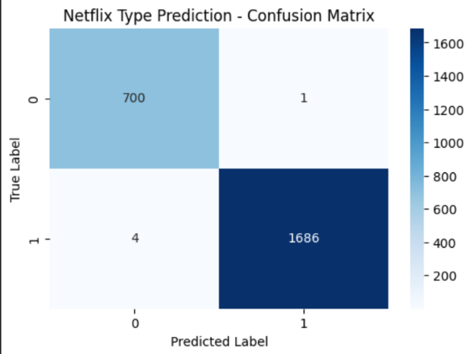
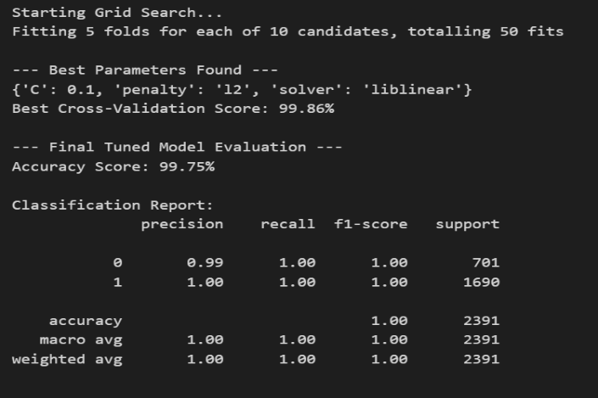

Code & Output (with hyperparameters):
import pandas as pd
from sklearn.model_selection import train_test_split, GridSearchCV from sklearn.linear_model import LogisticRegression
from sklearn.metrics import classification_report, accuracy_score param_grid = {
'C': [0.001, 0.01, 0.1, 1, 10, 100, 1000],
'penalty': ['l1', 'l2'], 'solver': ['liblinear']
}
logmodel = LogisticRegression()
grid_search = GridSearchCV(estimator=logmodel, param_grid=param_grid, cv=5, verbose=1, scoring='accuracy')
print("Starting Grid Search .") grid_search.fit(X_train, y_train) print("\n - Best Parameters Found -") print(grid_search.best_params_) print(f"Best Cross-Validation Score:
{grid_search.best_score_*100:.2f}%") best_model = grid_search.best_estimator_ grid_predictions = best_model.predict(X_test) print("\n - Final Tuned Model Evaluation -") print(f"Accuracy Score: {accuracy_score(y_test, grid_predictions)*100:.2f}%") print("\nClassification Report:")
print(classification_report(y_test, grid_predictions))

